Computer Security Overview and Best Practices
Student Name: Zhumabay Nurdaulet
Date: October 03, 2026
Course / Module: Computer Software Setup and Security (PM03)

1. Introduction to Computer Security
Computer security (cybersecurity) is the practice of protecting computer systems, networks, and sensitive digital data from unauthorized access, malicious attacks, theft, or damage. In a modern workstation environment, maintaining a secure computer configuration is essential for preserving data integrity, confidentiality, and operational continuity.
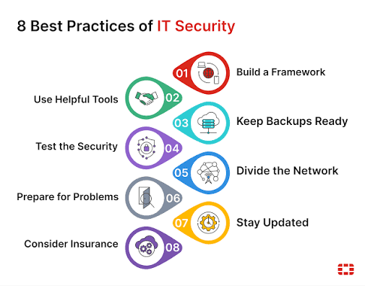

2. Pillars of Workstation Protection
A robust defense strategy for a office PC relies on a multi-layered approach:
- Official Drivers and Software: Installing drivers and software exclusively from official manufacturers prevents malware infection and ensures system stability.
- Antivirus & Real-Time Protection: Continuous background scanning isolates malicious binaries and suspicious downloads before execution.
- Network Firewall: Filters incoming and outgoing network traffic to block unauthorized remote connections.
- Automated Updates: Regular operating system and software patches fix security vulnerabilities before they can be exploited.
- Data Backup & Recovery: Periodic backups ensure business continuity in case of hardware failure or ransomware threats.

3. Security Measures and Risk Level Summary
Security Component | Primary Threat | Recommended Configuration | Risk Level
Antivirus Software | Malware, Ransomware, Trojans | Real-time scanning enabled; auto-updates active | High
Hardware Drivers | System instability, Unpatched exploits | Downloaded only from verified vendor websites | High
Network Firewall | Port scanning, Unauthorized access | Active on Private and Public network profiles | Medium
User Authentication | Brute-force, Credential theft | Complex passwords and Multi-Factor Authentication | High

4. Multi-Layer Security Architecture
[ Workstation Defense Architecture Diagram ]

User Terminal → Network Firewall → Real-Time Antivirus → Verified Drivers & OS Patching → Encrypted Data Storage

